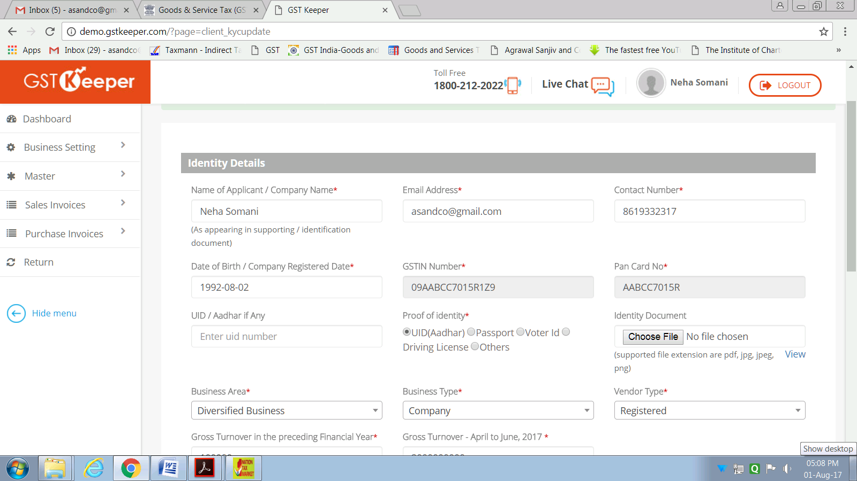

1. Cannot enter or update GSTIN Number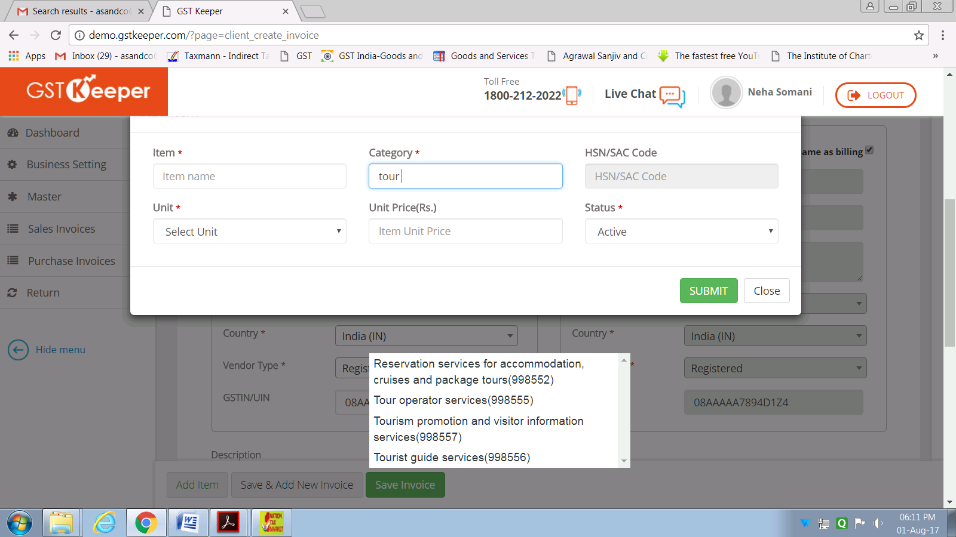
2. Can the list of Category be fixed on its place and not moving with the background screen

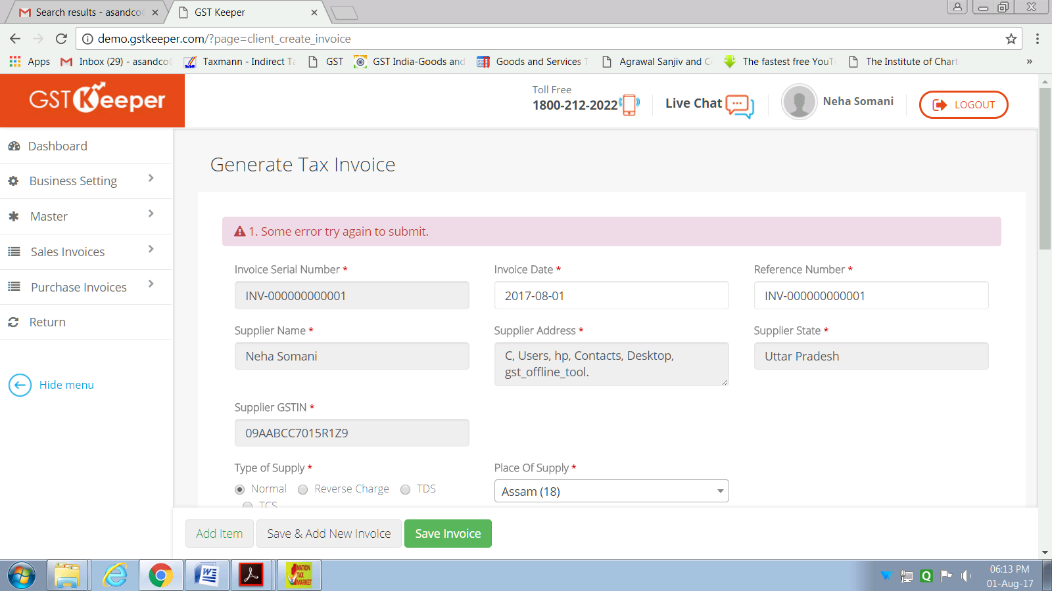

1. Invoice could not be saved.
2. Invoice serial number should be editable.

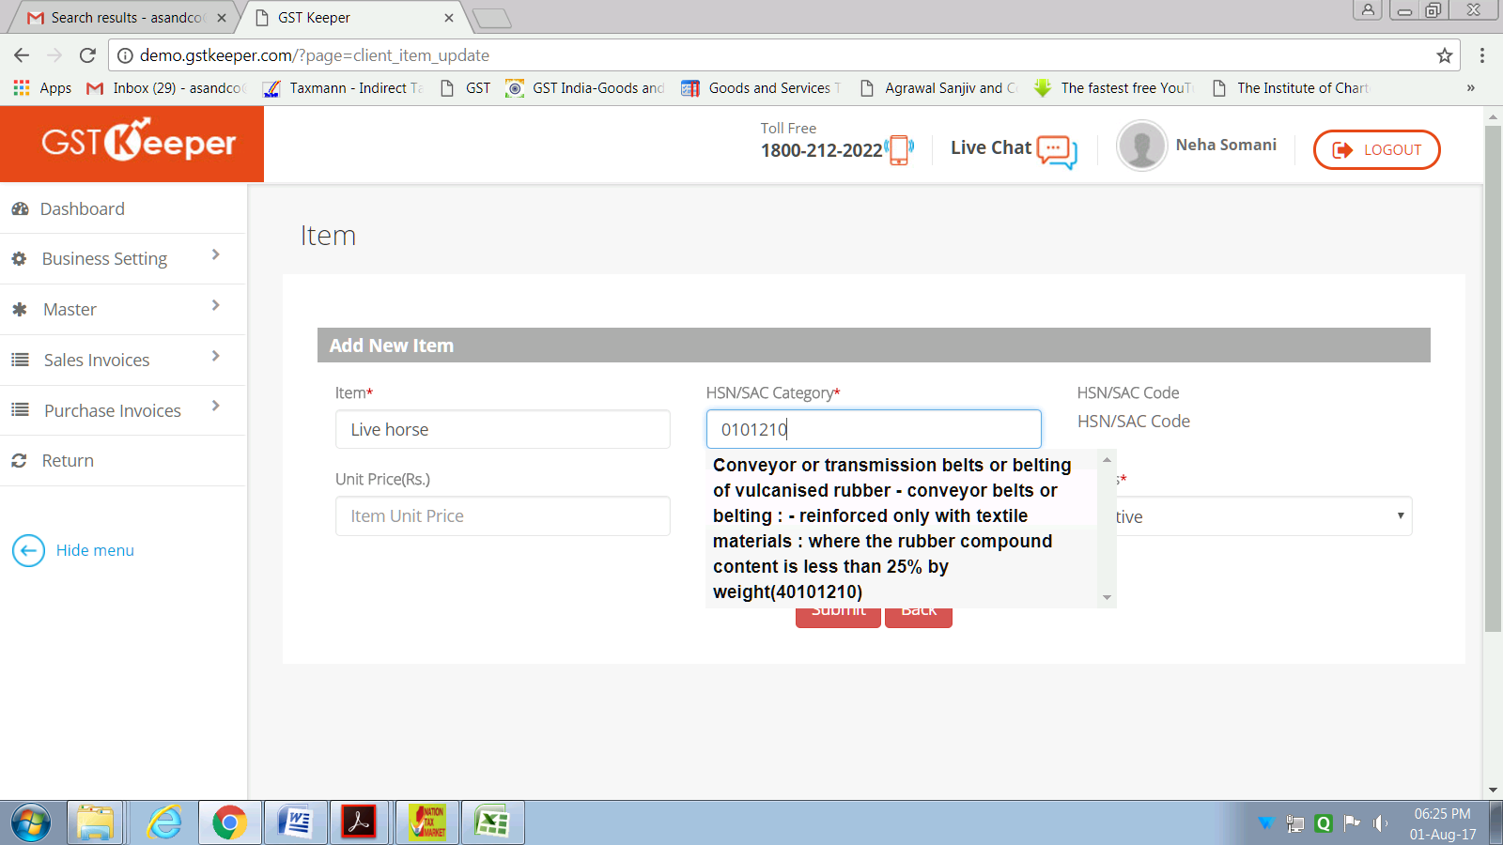

1. All the HSN codes are not available in the HSN list (for e.g. 01012100 for live horses is not in the list).

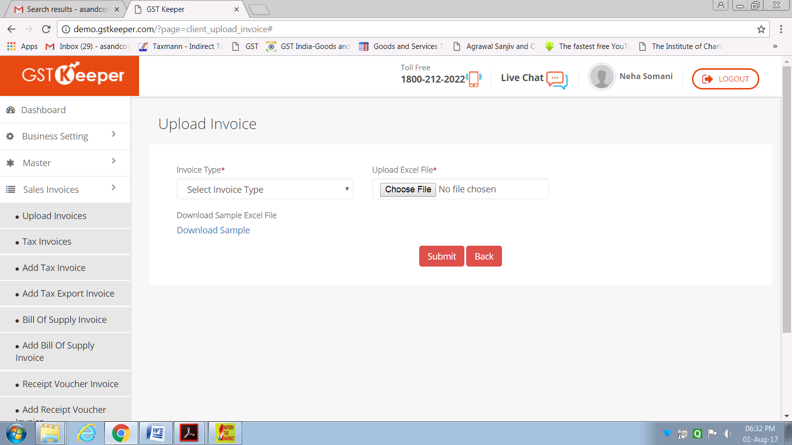

1. Complete list of sales invoices menu is not viewable as it could not be scrolled down.

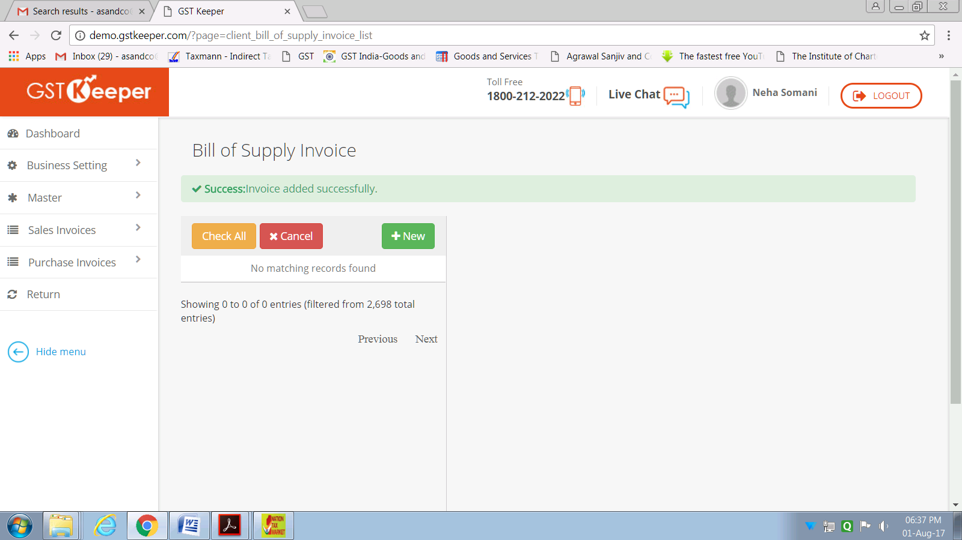

1. Any of the uploaded invoices cannot be viewed, both sales and purchases, though it shows that the invoices are added successfully.
2. GSTR-1 could not be filled.
3. At least some part of GSTR-3B should be auto-filed.
4. On GSTR 1 Summary page taxable amount should be excluding of tax.

